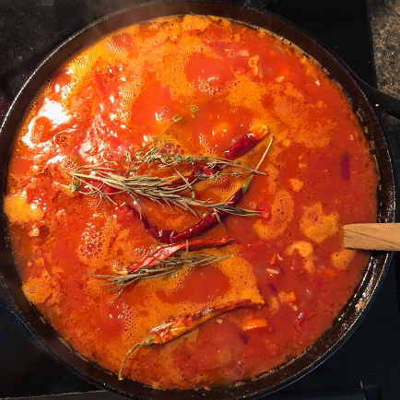
Pasta Marinara
I started working on this marinara recipe when I was in grad school and refined bulk production when I was pregnant. There’s almost always a few jars in our freezer: we either use it as is, cook it down to use as a pizza sauce, or jazz it up with meatballs, olives, or fried eggplant. You can even blend it, add some broth and turn it into a soup. I usually spend a Sunday afternoon with the marinara bubbling on the stove for several hours - although it’s ready to eat after about an hour. The sauce deepens in color and flavor over time, so keep it on for as many hours as you can spare. This is a staple in our home and we hope you find it as versatile, forgiving, and comforting as we have.
Serves 6-8
Prep Time 20 mins
Cooking Time 1-4 hours

Ingredients
For the Marinara | Substitutions/Notes
4 x 28 oz cans, crushed or whole tomato | Or equivalent weight in fresh tomatoes
1 large red onion  + 1 large yellow onion, diced | Or approx 700g of any chopped onion
3-4 carrots, diced | Approx 200g
10-15 cloves garlic, minced
1 tbsp salt
½ tbsp chili powder | Either cayenne or paprika, mood dependant
4 whole dried red chili | Usually arbol chiles
2 whole sprigs dried thyme  + 2 whole sprigs rosemary | Or whatever you have fresh/dried available, e.g., Or 1tbps dried mixed herbs/herb de provence.
1 cup olive oil
Make it a Meal
Linguine, 80g dried per person | Or any pasta
Parmesan, as you like | Or crushed toasted pine nuts, if non-dairy

Instructions
- Make Marinara Sauce
  - Heat olive oil on medium fire in a deep pot. When shimmering, add onions and cook till translucent.
  - Add garlic, cook till fragrant.
  - Add carrots, cook till soft.
  - Add tomatoes, including liquid. Add salt, chili, and herbs.
  - Leave to bubble on low to medium heat for 1-3 hours. The goal is to have the pot bubbling gently, cooking down the water a little bit. The color will become a deep orange-red when it is cooked. You can’t overcook the sauce, you just want it to smell fragrant and feel thick.
  - Set aside once done (freeze what you don’t use in 2 cup portions).
- Cook & Assemble Pasta.
  - In a new pot, bring water to a boil. Add pasta, and cook till soft but with a bite, about 8-9 minutes.
  - Drain the pasta and empty the pot.
  - Put marinara (use about a cup of marinara per person) into the pot and bring to a bubble again. Add cooked pasta. Add any extra ingredients you like at this time too (e.g., olives, meatballs, or fried eggplant). Mix well without breaking the noodles till everything is coated with sauce and it is evenly heated.
  - Place servings in bowls. Add parmesan or pine nuts as desired.

References
There are five sources plus my own tweaks that led to this recipe. First, I used the Cook’s Illustrated recipe for a quick 15 minute marinara: the special thing that stuck is the use of a cast iron pot. I still, controversially, cook my sauce in a very well seasoned cast iron pot because I think that it brings a richness I don’t get in my steel stock pot. Second, I use Alice Waters guidance on timing and, when fresh tomatoes are in season, will use her guidance on tomato conversion. I found Alice’s recipe wasn’t spicy enough for my tastes so I then looked at Marcella Hazan’s work: she taught me methods for Italian cooking, so I incorporated ideas from her recipe for tomato sauce with vegetables and oil. Finally, the method for assembling the sauce with the pasta comes from the character Artie Buco in the TV show The Sopranos. He run’s the mob’s favorite restaurant and there’s a scene where he plops the pasta back into the warm sauce on the stove giving it a slightly starchier, richer texture.

Recipe Contributor: Ankita

